EXPERIMENT - 4
Set 4: Product Inventory Management

Dataset: Product Inventory
Product ID | Product Name | Quantity Available
1 | Product A | 250
2 | Product B | 175
3 | Product C | 300
4 | Product D | 200
5 | Product E | 220

Question 1
Create a bar chart to visualize the quantity of each product in the inventory. Label the axes and title the chart.

R Code
# Set 4 - Q1: Bar chart of quantity available per product
product_name <- c("Product A","Product B","Product C","Product D","Product E")
quantity <- c(250, 175, 300, 200, 220)

barplot(quantity, names.arg = product_name,
main = "Quantity Available by Product",
xlab = "Product", ylab = "Quantity Available",
col = "seagreen", ylim = c(0, max(quantity) + 50))

Output
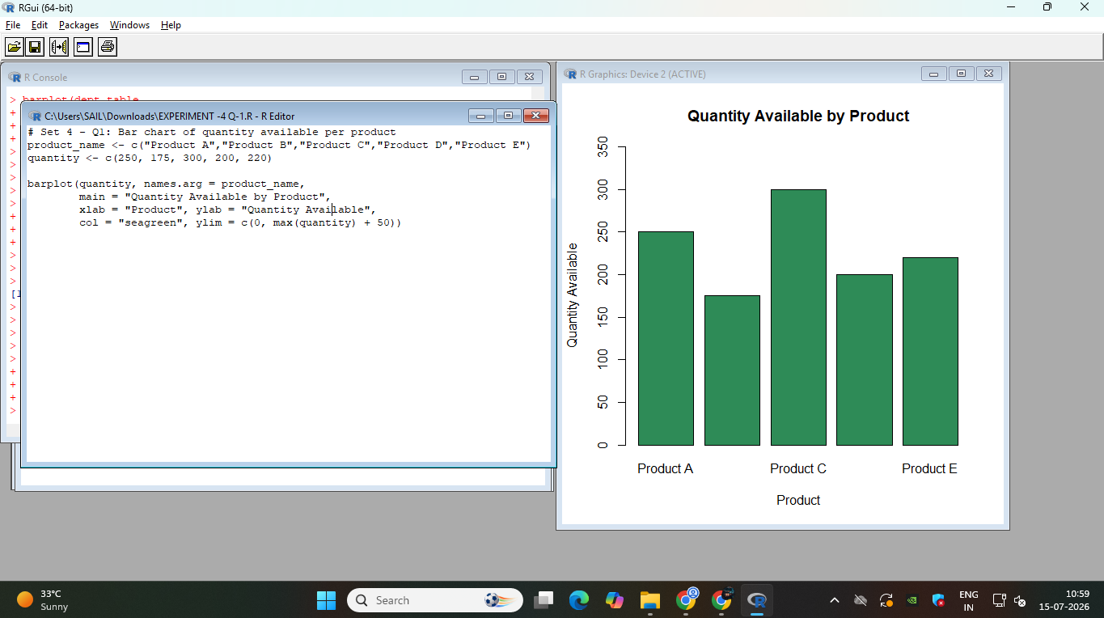

Question 2
Generate a stacked bar chart to show the quantity of each product within different product categories.

R Code
# Set 4 - Q2: Stacked bar chart - quantity by product category
product_name <- c("Product A","Product B","Product C","Product D","Product E")
quantity <- c(250, 175, 300, 200, 220)
category <- c("Electronics", "Clothing", "Electronics", "Grocery", "Clothing")

# Build a matrix: rows = product, columns = category
tab <- tapply(quantity, list(product_name, category), sum)
tab[is.na(tab)] <- 0

barplot(t(tab), beside = FALSE,
main = "Product Quantity by Category",
xlab = "Product", ylab = "Quantity Available",
col = rainbow(ncol(tab)),
legend.text = colnames(tab),
args.legend = list(title = "Category", x = "topright"))

Output
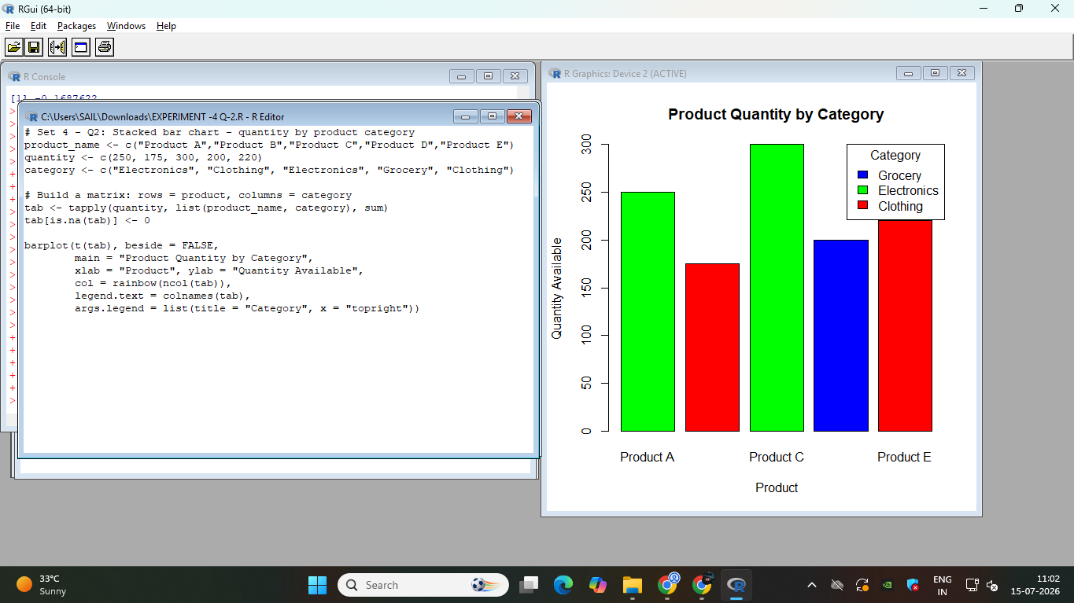

Question 3
Build a scatter plot to explore the relationship between product price and quantity available. Explain the findings.

R Code
# Set 4 - Q3: Scatter plot - product price vs quantity available
product_name <- c("Product A","Product B","Product C","Product D","Product E")
quantity <- c(250, 175, 300, 200, 220)
price <- c(20, 35, 15, 28, 22) # sample data ($)

plot(price, quantity,
main = "Product Price vs Quantity Available",
xlab = "Price (in $)", ylab = "Quantity Available",
pch = 19, col = "brown")
abline(lm(quantity ~ price), col = "blue", lwd = 2)

# Calculate and print the correlation
correlation <- cor(price, quantity)
cat("Correlation between Price and Quantity Available:", round(correlation, 3), "\n")

# Auto-generated finding based on the correlation value
if (correlation < -0.5) {
cat("Finding: There is a strong negative correlation between price and quantity available.\n")
cat("This suggests that lower-priced products tend to be stocked in higher quantities,\n")
cat("possibly because they have higher turnover or are prioritized for bulk inventory.\n")
} else if (correlation > 0.5) {
cat("Finding: There is a strong positive correlation between price and quantity available.\n")
cat("This suggests that higher-priced products are being stocked in larger quantities.\n")
} else {
cat("Finding: There is a weak or negligible correlation between price and quantity available.\n")
cat("This suggests that price alone does not strongly determine how much of a product is stocked.\n")
}

Output
